Web Lab Assignment

Team:

* Sai Sampath Kumar Raigiri – 32
* Anvesh Mandadi - 22
* Chandra Shekar – 30

Objective:

The Main Objective of this assignment is to develop an Angular application to provide services to University Students which Includes all kinds of information of their academic. This application has to use Node, Express and Mlab to save the data and retrieve the data.

Features of the Application:

1. User Account details (Sign-In, Sign-Up)
2. Single studentdetails (Name, contact information)
3. Courses(Include all the courses enrolled)
4. Books(Can link to UMKC bookstore)
5. Calendar

Technologies Used:

1. Angular 8
2. NodeJs
3. Express Js
4. Mongo DB

Output:

SignIn Page:

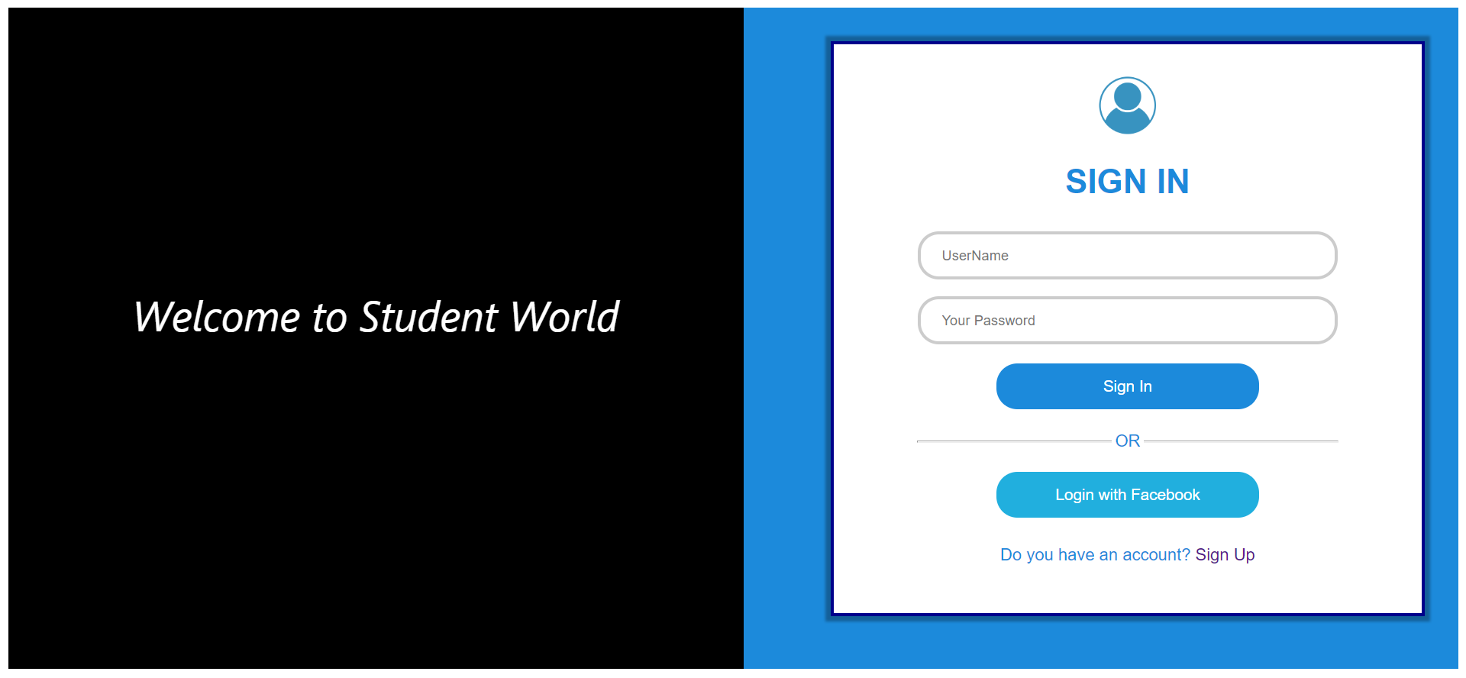

SignUp Page:

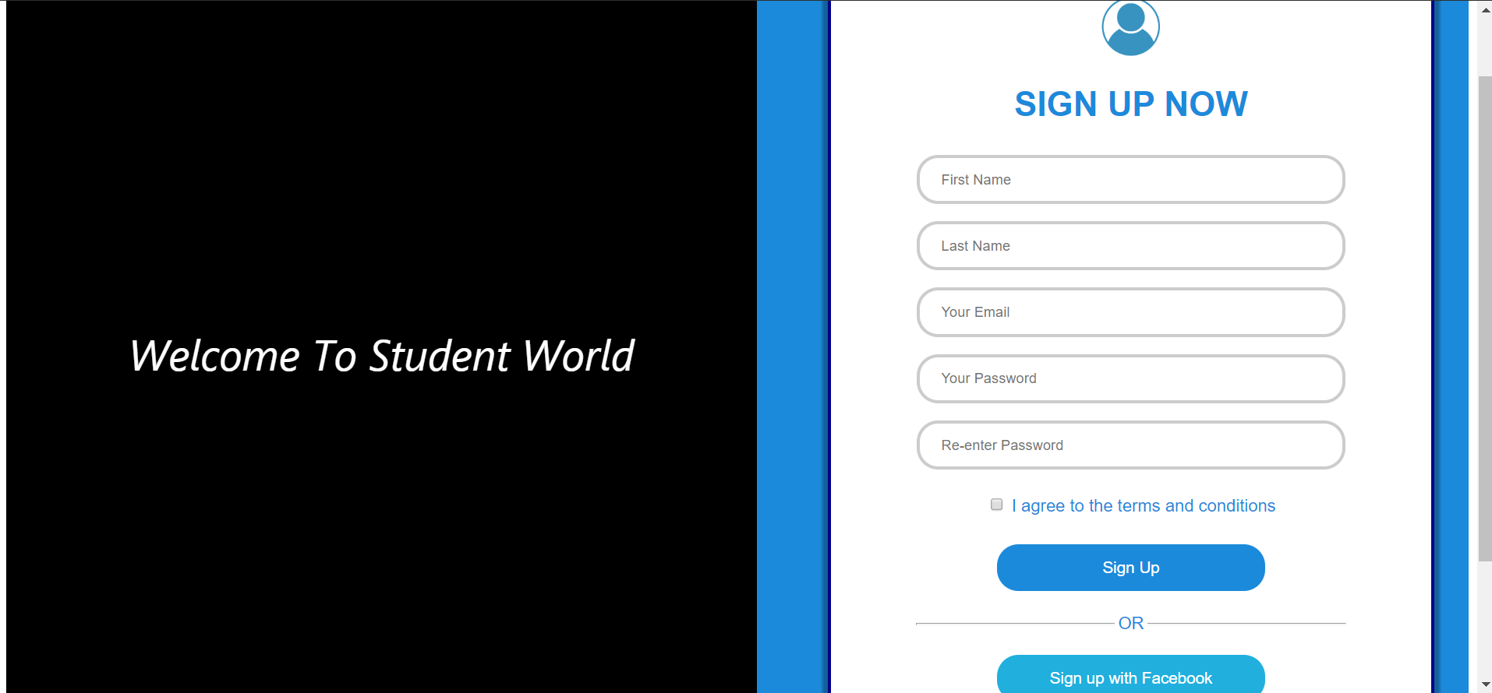

Profile Page:

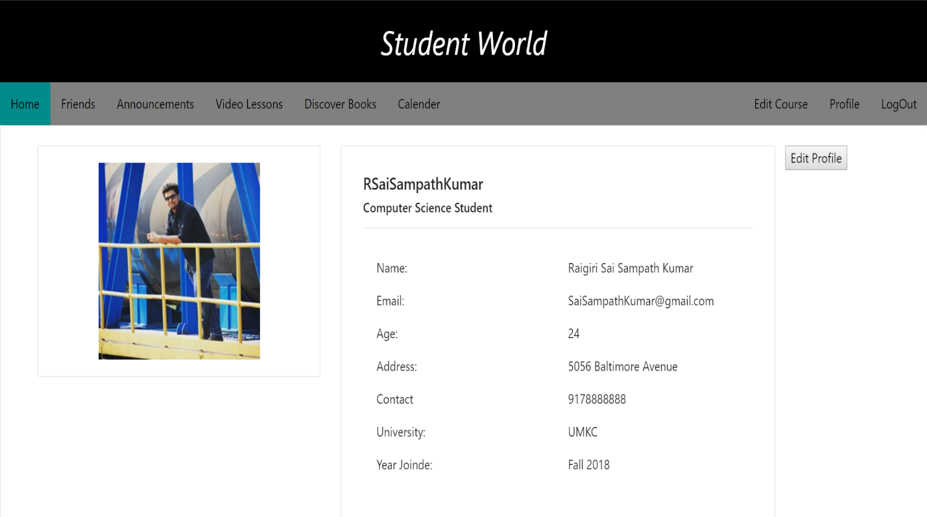

Home Page:

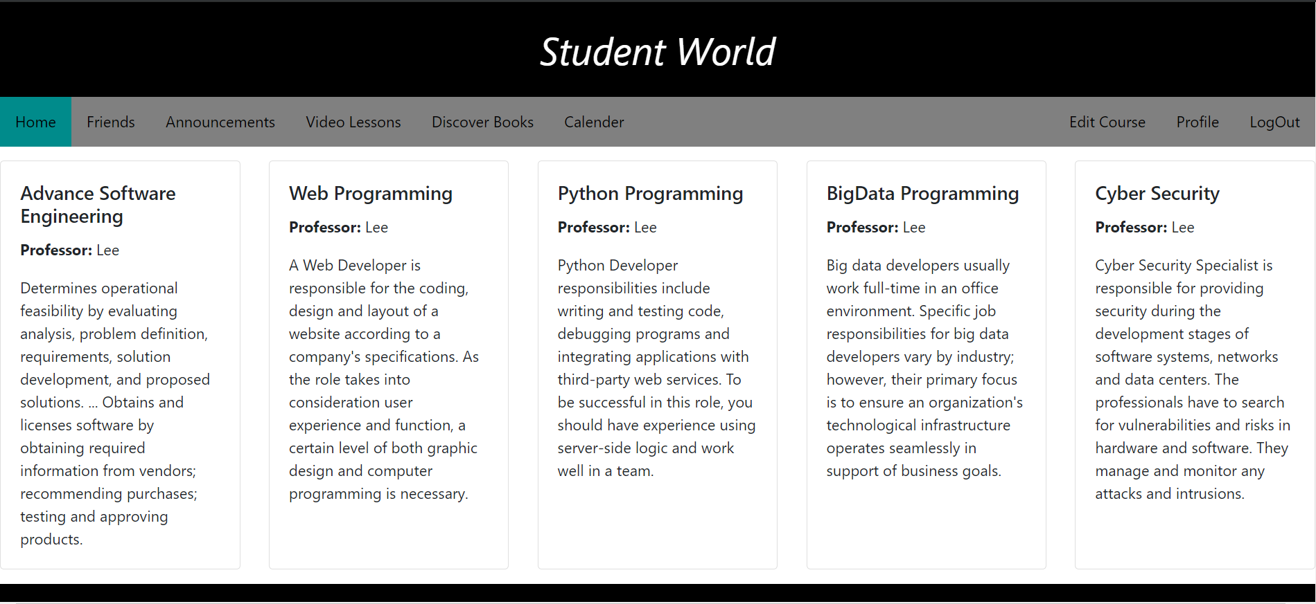

Friends Page:

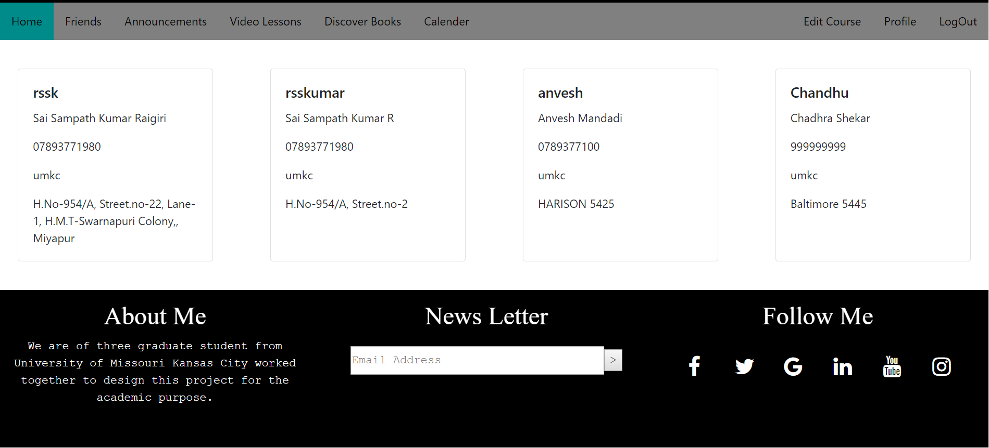

Callender Page:

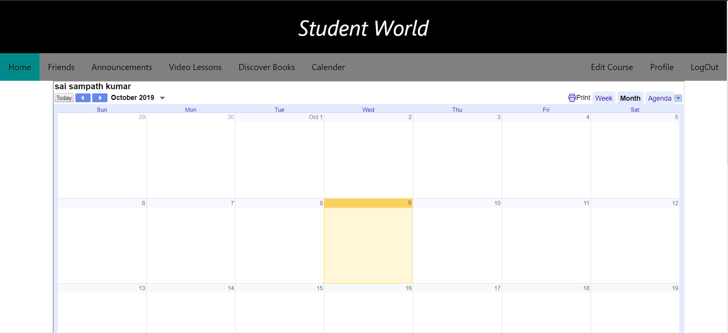

News Page:

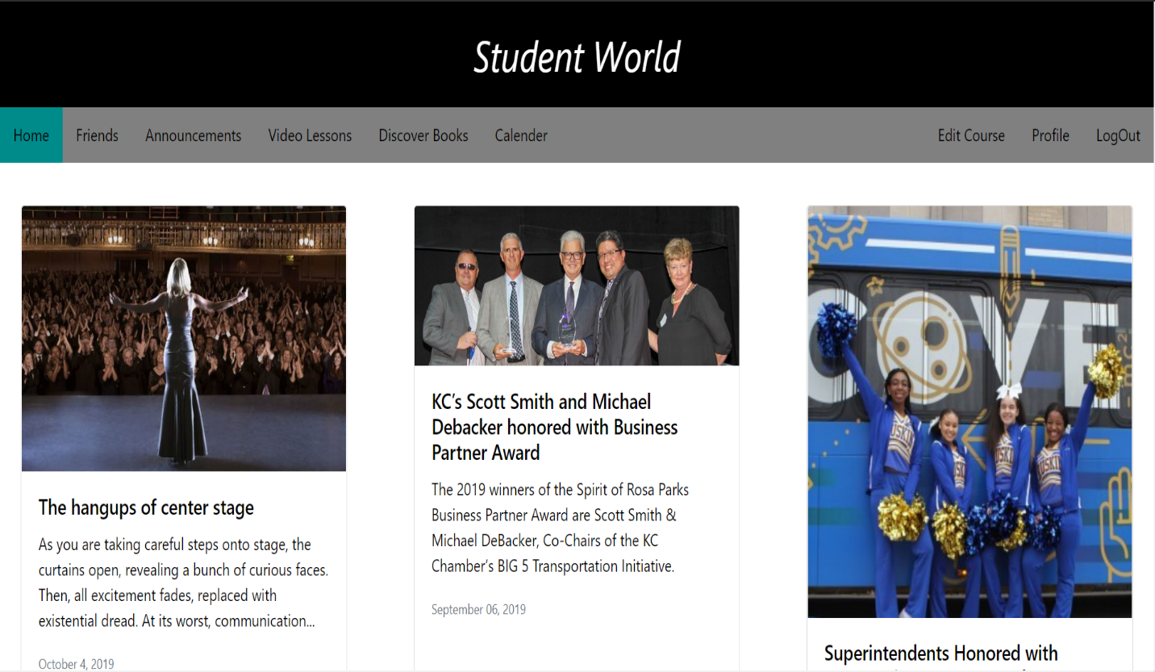

Video Lessons Page:

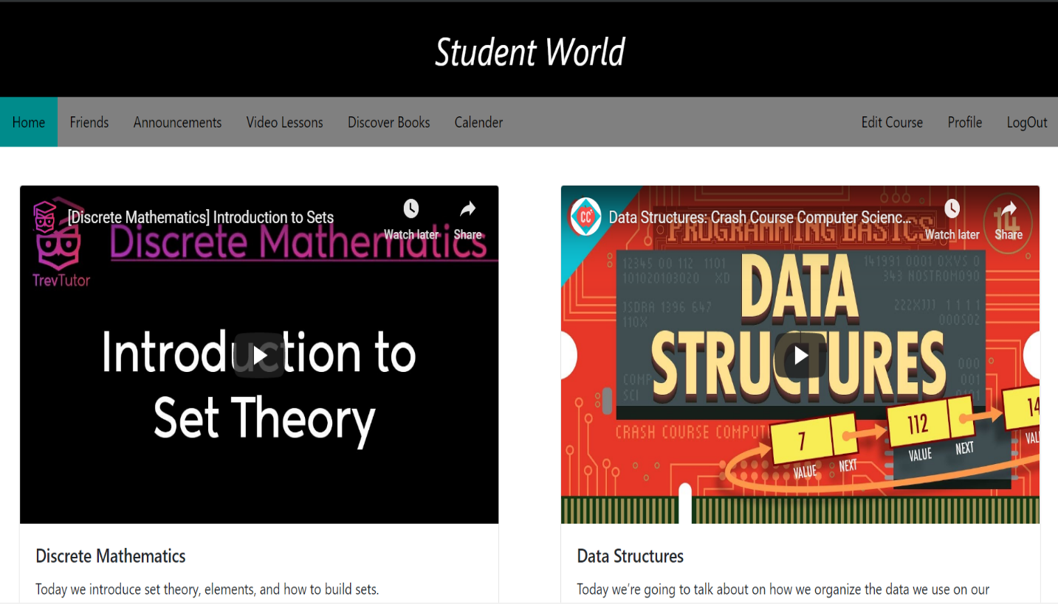

Data in Mongo Db:

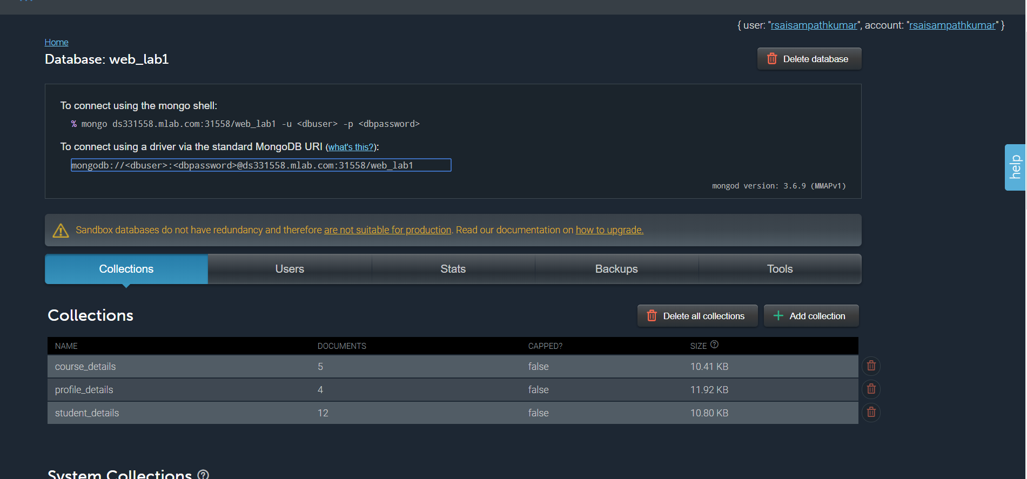

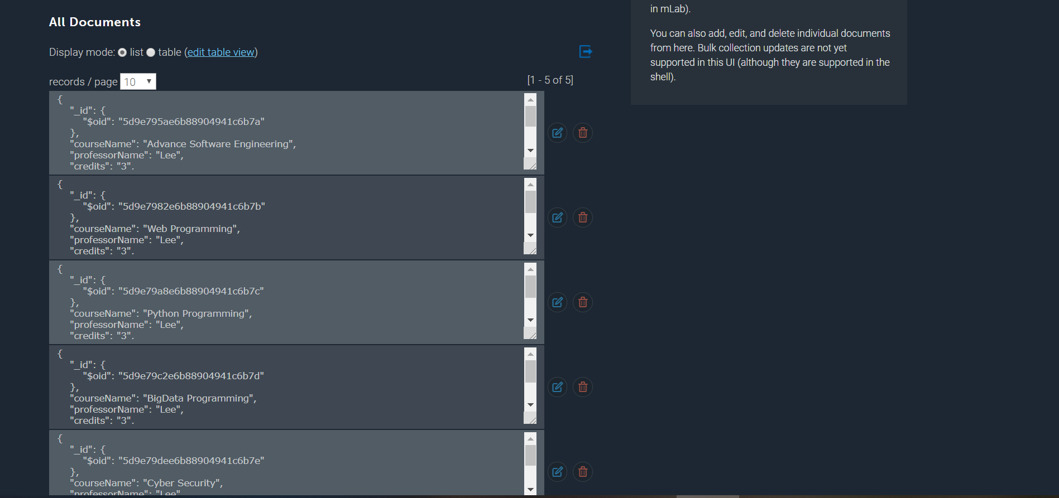

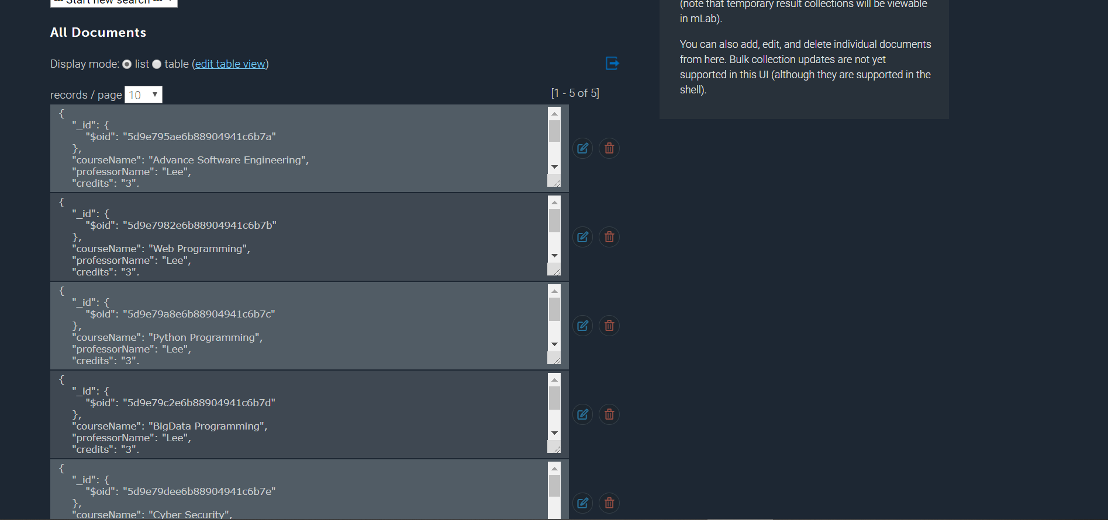

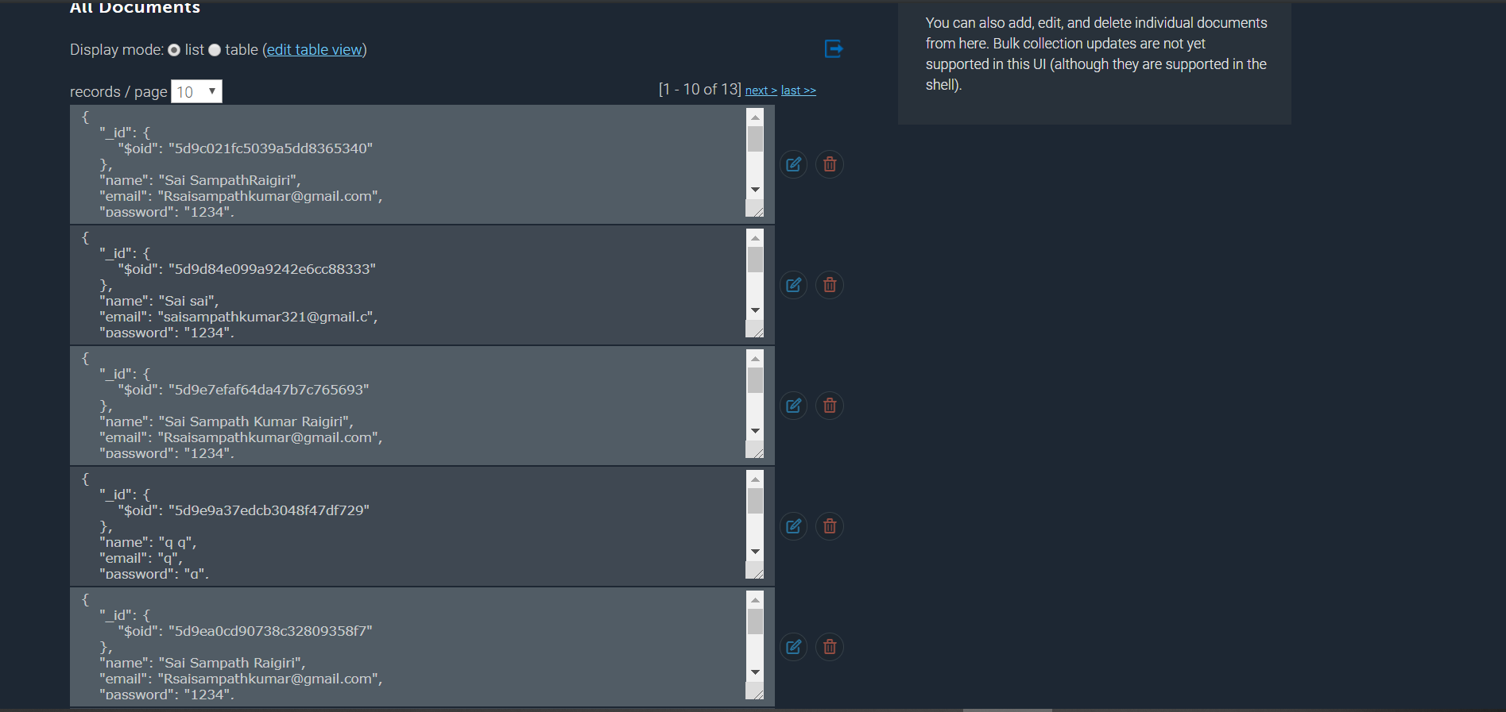

CONCLUSION:

We have completed a fully working Mean Stack Application

GITHUB PAGE:

<https://github.com/saisampathkumar/Web_Lab>

WIKI PAGE:

<https://github.com/saisampathkumar/Web_Lab/wiki/Lab-Assignment-1>

VIDEO LINK:

https://youtu.be/mE52muD2n2Y